- Briefly explain the concept of zero trust.
Zero Trust is a security model that assumes no implicit trust in any user, device, or network—whether inside or outside the organization. It enforces continuous verification and grants access based on strict identity, device, and context checks, minimizing the risk of breaches by always verifying “never trust, always verify.”

- Active Directory Domain Services are used to store which kind of objects? Which container in ADDS is used to store these objects?
User accounts, computer accounts, and groups.
Domain container.

- Which services is used to synchronize information between ADDS and Entra ID? Which objects are synchronized?
Entra ID Connect or Azure AD
User accounts, computer accounts, and groups.

- Explain options for password hash sync between ADDS and Entra ID.
Option 1: No Sync
Option 2: One-way Sync, no changes on cloud allowed.
Option 3: Two-way sync, changes on cloud allowed.

- Which service allows an administrator to block user access if he is outside his country of residence?
Conditional access.

- How would you configure Entra ID to allow only admins to login with MFA but not the regular users?
By enabling conditional access.

- How and why secure score is calculated by defender for cloud?
Defender for Cloud continually assesses your resources for security issues; then aggregates all the findings into a single score so that you can tell your current security situation.

- Briefly describe functionality and usage of Microsoft Entra ID service.
Microsoft Entra ID (formerly Azure AD) is a cloud-based identity and access management service. It provides authentication, single sign-on (SSO), and access control for users and applications. It’s used to manage user identities, enforce multi-factor authentication, and protect resources with conditional access policies, enhancing security for cloud and hybrid environments.

- Draw & briefly explain the process of synchronization of AD objects to Entra Domain Services.
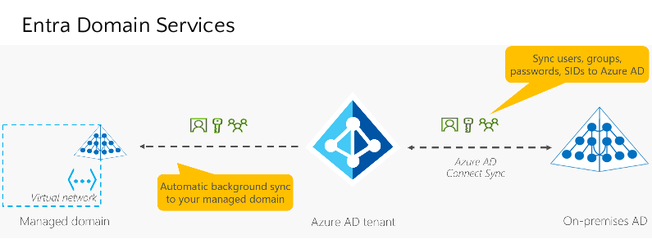

- Briefly explain the concept and principles of zero trust.
Zero Trust is a security model that assumes no implicit trust in any user, device, or network—whether inside or outside the organization. It enforces continuous verification and grants access based on strict identity, device, and context checks, minimizing the risk of breaches by always verifying “never trust, always verify.”

- How and why secure score is calculated by defender for cloud?
Defender for Cloud continually assesses your resources for security issues; then aggregates all the findings into a single score so that you can tell your current security situation.

- What are the different options to sync password hash between ADDS and Entra ID.
Option 1: No Sync
Option 2: One-way Sync, no changes on cloud allowed.
Option 3: Two-way sync, changes on cloud allowed.

- As an administrator, you want to block user access if a user is outside his country of residence. How would you accomplish that?
By enabling Conditional access.

- Which objects are stored in ADDS? Which container type in ADDS is used to store these objects?
User accounts, computer accounts, and groups.
Domain container.

